

**HealthTrust Europe LLP: ITT to establish a framework agreement for consultancy solutions and advisory services Contract Notice (FTS) Ref: 2023-041574**

**Technical Response – H1_Continuous Improvement and Sustainability_Ethical Healthcare Consulting**

H1: Please provide details of your sustainability plan. Such details should include:

• a sustainability plan which covers water usage, carbon footprint, greenhouse gasses;

• confirmation including details that show annual targets year on year have been met; and

• an example of a recycling program adopted in the last 3 years.

**EHC Response:**

EHC has provided supplementary information within supporting documentation below for this section:

***‘SD12 Virtual Office Management Policy’***

***‘SD13 EHC Carbon Footprint Policy’***

***‘SD14 EHC Carbon Reduction Plan’***

* **a sustainability plan which covers water usage, carbon footprint, greenhouse gasses;**

Ethical Healthcare recognise the importance of environmental sustainability and aim to promote good environmental practices amongst all our people. **‘SD12 Virtual Office Management Policy’** and **‘SD13 EHC Carbon Footprint Policy’** outlines guidelines and expectations for our teams to help reduce their environmental footprint whilst working from home.

This policy is reviewed annually to align with evolving environmental standards and practices.

**Energy Efficiency**

We encourage employees to utilise power-saving features on electronic devices, such as enabling sleep mode, screen savers, and automatic shutdown options. Devices should be turned off when not in use.

**Make use of natural light whenever you can, when working.**

Reducing environmental impact by having indoor plants. They improve the quality of air and remove toxic chemicals inside the house – enhancing mental state.

**Paperless Operations**

As a remote-based company, we operate digitally and routinely use digital documents. This includes sharing files electronically, using digital signatures, and storing documents in cloud-based platforms. We prioritise digital documents whenever possible, reducing the need for printing.

In cases where printing is necessary, employees are encouraged to print double-sided, use recycled paper, and recycle printed documents responsibly.

**Waste Reduction**

We encourage employees to actively participate in local recycling programs and ensure that recyclable waste, such as paper, cardboard, plastics, and glass, is separated and disposed of properly according to local recycling guidelines.

A good way to reduce paper waste could be to:

* Keep one-sided printouts (if any) to use as notepaper
* Recycling any magazines or newsletter they have at home by donating them to their local library, dental practice or nursing home.

**Sustainable Purchasing**

When purchasing office supplies, eco-friendly options, such as recycled paper, pens made from sustainable materials, and reusable office products, should be prioritised. Here are a few examples of such vendors we suggest:

* <https://www.greenstat.co.uk/>
* <https://www.thegreenoffice.co.uk/>
* <https://www.avansas.com/uk/>
* <https://freecycle.org/>

**Transportation and Commuting**

Remote working eliminates the need for daily commuting, reducing carbon emissions and traffic congestion.

When commuting is necessary, employees are encouraged to use eco-friendly modes of transportation, such as public transportation, carpooling, cycling, or walking, where possible.

**Communication and Collaboration**

As a remote-based company, we consistently use video conferencing and online collaboration tools to minimise the need for travel and face-to-face meetings.

Employees are encouraged to prioritise digital communication methods (email, instant messaging, project management platforms) to reduce the need for printed materials and postal services.

**Water reduction**

Given that our organisation operates without a central office, with many employees working from home, traditional approaches to sustainability in a workplace setting might not directly apply. However, we encourage employees and consultants to practice responsible environmental practices.

**B-Corp Accreditation**

B Corp is a certification awarded to businesses that meet rigorous social and environmental performance standards. EHC are pursuing B Corp certification to demonstrate our commitment to operating ethically and sustainably, in the best interest of our employees, customers, stakeholders and wider networks. B Corps are driven by a triple bottom line—people, planet, and profit. By obtaining B Corp certification, we are seeking to evidence that we prioritise social responsibility, transparency, and long-term sustainability, aligning with the growing demand for businesses to contribute positively to the world. We have submitted and are actively in the B Corp assessment queue.

* **confirmation including details that show annual targets year on year have been met; and**

EHC have recently published a Carbon Reduction Plan. Publishing a carbon reduction plan at EHC is not just about addressing environmental concerns; it's also deeply rooted in our identity as an SME committed to community development. As a small and agile organisation our status enables us to deliver tailored, impactful services to our clients, aligning perfectly with government policies that emphasise SME participation in supply chains to generate social value. Our dedication to community engagement and creating a positive impact, positions us as a natural choice for projects that seek to make meaningful contributions to society. Our carbon reduction plan is an extension of our broader social value commitments, demonstrating how we integrate environmental responsibility with our core values.

The total calculated emissions for the business in 2022/2023 are 12 t CO2e. This is the first year the company has measured it carbon emissions (from May 2022 – April 2023). As such this is the benchmark year of EHC with the breakdown of emissions analysed within our Carbon Reduction Plan. EHC will aim to measure an increasing amount of Scope 3 emissions and is committed to improving their emissions across all scopes.

The following graph summarises EHC’s carbon emissions reduction targets.

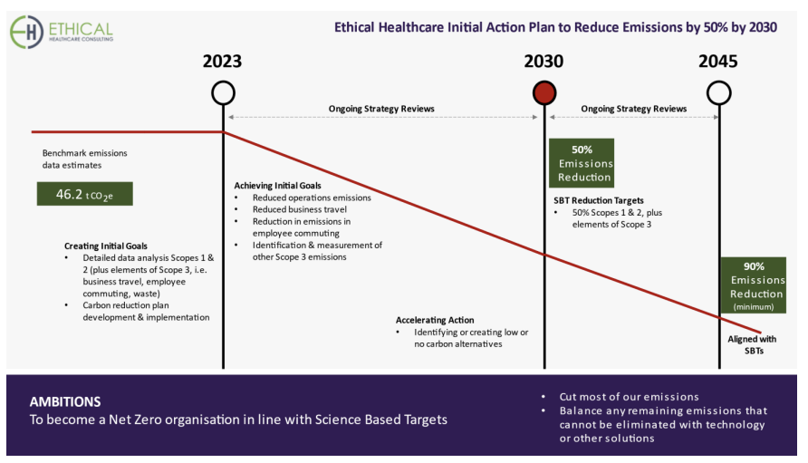

Further information on our targets and commitments can be found with our Carbon Reduction within our supporting documents ‘***SD14 EHC Carbon Reduction Plan’.***

* **An example of a recycling program adopted in the last 3 years.**

As a remote company, EHC faces unique challenges in implementing traditional office-based recycling initiatives. However, we are committed to promoting sustainable practices among our employees, including encouraging them to recycle at home.

Regarding company assets, specifically laptops provided to staff, EHC recognises the importance of ethical disposal of electronic waste. To address this, we have identified two reputable companies to assist with the responsible recycling of laptops once they reach the end of their lifecycle:

* YCS Computers: <https://www.ycscomputers.uk/> - YCS Computers offers services for the ethical recycling of electronic equipment, ensuring that all components are either reused or recycled in an environmentally friendly manner.
* Revive IT: <https://www.reviveit.co.uk/> - Revive IT specialises in the secure and responsible disposal of IT equipment, adhering to stringent environmental standards.

By partnering with these companies, EHC will ensure that our electronic waste is handled responsibly, minimising our environmental impact and supporting sustainable practices in our operations.